**Project Title:** **WattWizards**

**User Manual**

**1. Introduction:**

**WattWizards** is an innovative software platform designed to assist electrical engineers and technicians in performing precise and efficient electrical circuit calculations. The application reduces the errors, enhances workflow efficiency, and offers tools such as workspaces (**Workspace**) and inventory management (**CircuitVault**) to improve user experience.

**This user manual provides guidance on how to use WattWizards effectively, including installation, key features, and troubleshooting.**

**2. System Requirements:**

**Web Application:**

- Compatible Browsers: Google Chrome (latest), Mozilla Firefox, Microsoft Edge and more.

- Internet Connection: Required for real-time updates and any other features.

**3. Getting Started:**

1. Navigate to the **WattWizards** official website.

2. Register for an account or log in if you already have one.

3. Access the application features where you can (upload/read/edit/delete) files (required/used) and use the features for better user experience.

4. Access the application programs that suits your case there is more than 12+ program.

**4. Key Features & Usage:**

**4.1. Electrical Calculation Tools (Programs)**

- Perform circuit breaker size calculations.

- Perform power factor correction calculations.

- Convert electrical units accurately.

- Supports AC/DC or 1/3 phase or different powers for efficient calculations.

- Supports historical physics programs.

- Supports data sets to be used in real time practices.

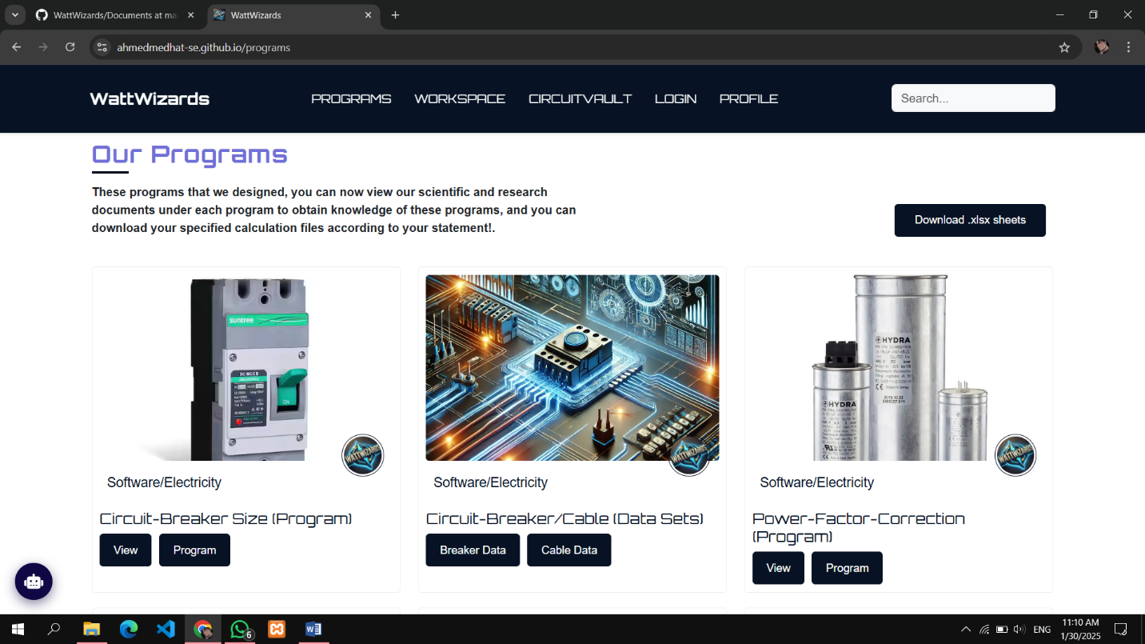

**4.2. Chatbot Assistance (SparkTalk)**

- Available on the web version for real-time guidance.

- Provides step-by-step application process (methodologies, references, background researches and more).

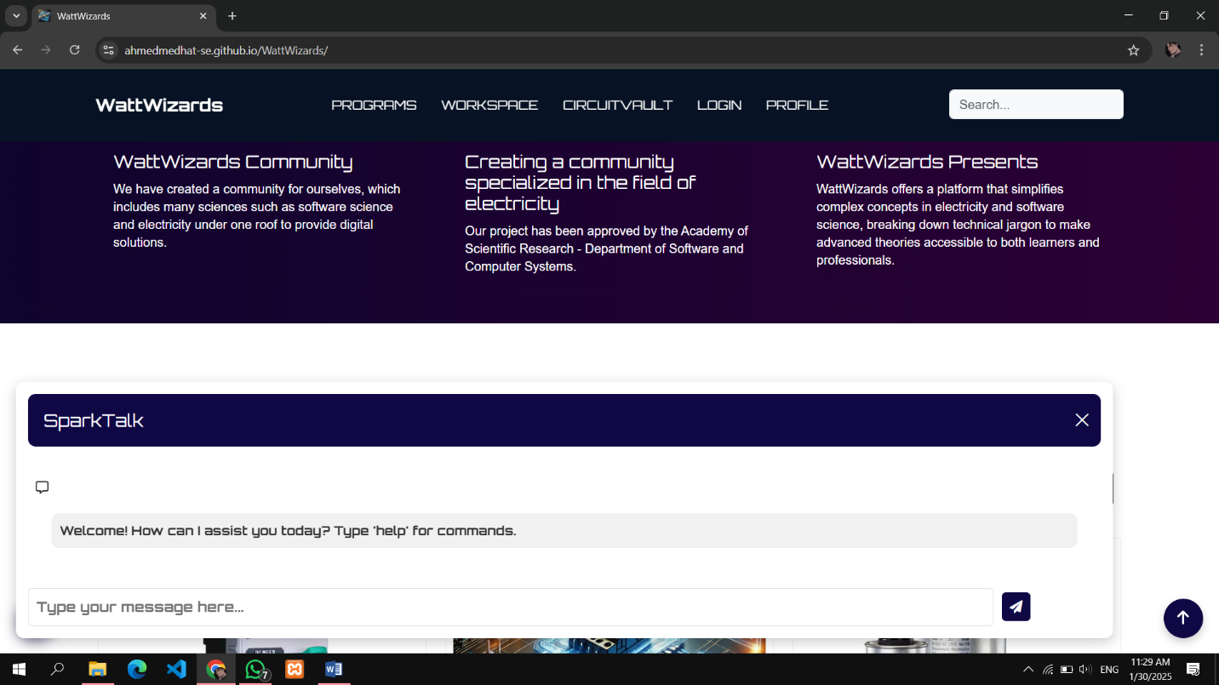

**4.3. Workspace**

**-** Access the download Excel sheet format template to handle massive data.

- Import/Export files in Excel format.

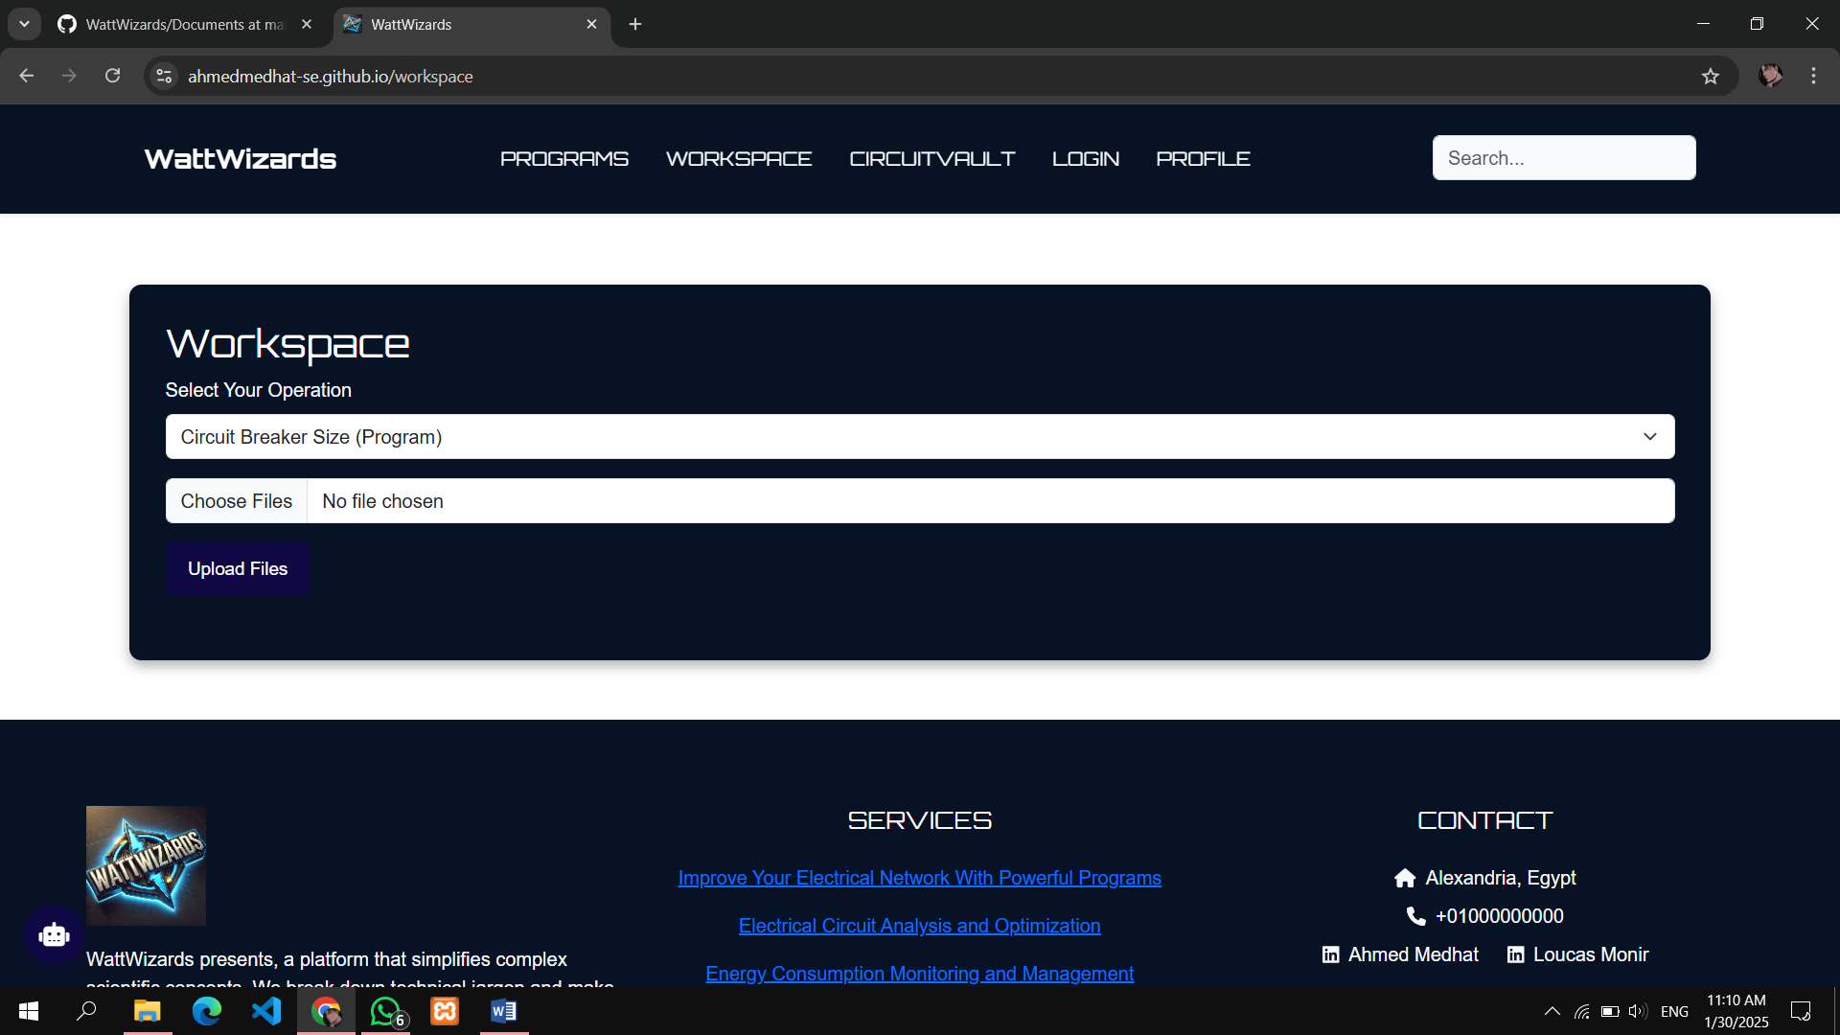

**4.4. Inventory & Project Management (CircuitVault)**

- Store and manage electrical data sheets.

- Organize projects into categories for easy retrieval.

- Track usage history.

- Save multiple circuit files and configurations.

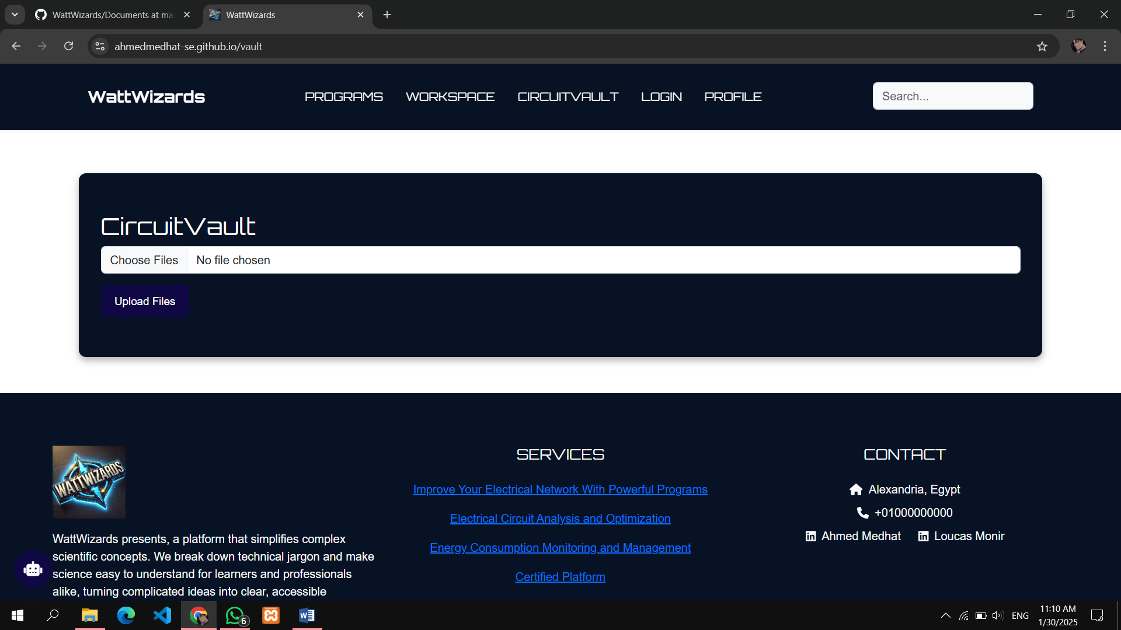

**4.5. Database Integration**

- Uses MySQL for secure data storage and retrieval.

- Ensures fast access to stored data.

- Regular automatic backups to prevent data loss.

**5. How to Use WattWizards**

**5.1. Procedures on Performing a Calculation**

1. Navigate to the "**Programs**" tab.

2. Select the desired type of electrical calculation (Circuit Breaker Size Calculator, Power Factor Correction, Electrical Consumptions, and more).

3. Enter the required values/data.

4. Click "**Calculate**" to generate results.

**5.2. Creating and Managing Workspaces**

1. Navigate to the "**Workspace**" tab.

2. Upload the file with required program needed.

3. Download the file responded from our system to see the results.

4. Save progress and return anytime.

**5.3. Managing Inventory (CircuitVault)**

1. Navigate to the "**CircuitVault**" tab.

2. Click "**Upload** **Files**" and you can modify file details and perform CRUD operations and can pin files in the pin section.

3. Use the **search bar** to find components quickly.

**6. Troubleshooting & FAQs**

**6.1. Login Issues**

- Ensure email and password are entered met the requirement.

- If login fails, clear browser cache or reinstall the application.

**6.2. Calculation Errors**

- Check input values for accuracy.

- Ensure all required fields are filled.

- Restart the application if the error persists.

**6.3. Chatbot Not Responding**

- Refresh the page and try again.

- Ensure a stable internet connection is available.

**6.4. Data Not Saving**

- Verify internet connection for storage features.

- Contact support if data loss persists.

**7. Contact & Support**

**For technical support or inquiries, please contact:**

- Community Forum: Available on the website for discussions and troubleshooting.

**End of User Guide.**